Optional File 03_azone_electricity_carbon_intensity
May 31, 2026

Definition of the Input File

VisionEval (https://visioneval.github.io/docs/model-inputs.html) uses this optional file to define the greenhouse gas emissions associated with electricity consumption. This is measured in grams of CO₂ equivalent per megajoule (gCO₂e/MJ). This file is not required—the user can simply omit it from the base run if desired. If the user chooses to use this file, the primary advantage is to tailor the output to local conditions. For example, the data below suggest that in year 2024, Albemarle will generate 87.3 gCO₂e per MJ of electricity, but year 2045 will see this value drop to 70.8 gCO₂e.

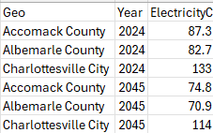

Possible Scenario

One primary scenario in VisionEval using this input is to examine how the decarbonization of the electrical grid influences the total greenhouse gas (GHG) reduction benefits of transitioning to electric vehicles.

As noted in A Playbook for Simplified Approaches for Creating Scenarios in VisionEval, users can explore how aggressive renewable energy mandates (like those in the Virginia Clean Economy Act) impact the "upstream" emissions of transportation. Lowering the carbon intensity value reflects a cleaner grid, which maximizes the environmental benefits of high EV adoption rates.

Method Used for Virginia

The EPA provides a greenhouse gas equivalencies calculator (https://www.epa.gov/energy/greenhouse-gas-equivalencies-calculator) for which one may enter a zip code and the number of kilowatt-hours used and one is returned the number of grams of CO2 equivalent. For each zip code, the research team entered 277.8 kwH as an input (which is equal to 1,000 MJ) and then as an output received the number of kgCO₂e; thus this number represented the number of grams per 1 MJ. (For example, for zip code 22003, entering the value of 277.8 kwh (which is 1,000 MJ) yields 82.7 kg of CO₂e; this means 87.2 g of CO₂e per 1 MJ).

The file https://genguide.com.ng/complete-list-of-all-virginia-zip-codes/ provides over 825 zip codes for Virginia’s cities and counties. For each city or county, the team choose the zip code with the largest population and used that in the calculator.

Almost all of the Azones had one of two values: 82.7 g of CO₂e per MJ or 133 g of CO₂e per MJ. (The three two exceptions were Lee County [124] and Accomack and Northampton Counties [87.3]. One reason for these differences appears to be that some regions in Virginia rely on natural gas power plants (see https://cleanview.co/power-projects/operating/natural-gas-power-plants/virginia) whereas other regions in Virginia rely on coal plants (see https://cleanview.co/power-projects/operating/coal-power-plants/virginia). Another reason may be differences in the extent to which these sources rely on solar and/or wind in addition to fossil fuel sources.

Forecasting changes for year 2045 entails some uncertainty. There are numerous online sources, one of which is from the Congressional Budget Office which in, 2022 (https://www.cbo.gov/system/files/2022-12/58419-co2-emissions-elec-power.pdf) forecast on printed page 12 several possible reductions in greenhouse gases from the electric power sector to year 2050. Two sets of reductions (High, reference or midcase, and low) were given—one for the situation prior to the 2022 budget reconciliation act and one following that situation. Factors influencing any actual reductions include shifts away from coal-fired plants, use of renewable sources such as solar and wind, and advances in battery technology; the graphs also underscore the relevance of public policy. For 2045, the research team applied a reduction of 14.3%, based on a reading of the 2045 reference case (1.4 billion metric tons) to the 2024 case (1.2 billion metric tons) prior to the budget reconciliation. For example, a figure of 82.7 g CO2e per MJ was used in 2024 for Amelia County. For 2045, this value is 70.9 g CO2e per MJ. Users can adjust these assumptions for changes specific to their region; for example, for a region using a coal power plant at present but which is planning a transition to natural gas in the next decade, then a much larger reduction would be applicable.

Appendix—Another Method

(Note that in the above calculations, single statewide value for the SERC egrid region covering North Carolina and Virginia, available at https://www.epa.gov/energy/greenhouse-gas-equivalencies-calculator-calculations-and-references, indicates 623 pounds of CO₂e per mWH which is 623* 453.59237 grams of CO₂e per mWH or 623* 453.59237 grams of CO₂e per 3600 MJ which is 78.5 grams of CO₂e per MJ—a value that is lower than those shown in this file. It appears that the reason is that the EPA calculator provides a marginal value rather than an average value; thus users could elect to reduce the figures shown slightly but the more critical element appears to be determining which region’s figures are applicable—that is, the value for the region containing Cumberland is substantially different from the value for the region containing Dickenson).

An alternative approach for future consideration is to explore the EPA AVERT Web Edition tool( AVERT Web Edition | US EPA AVERT provides regionally specific emissions estimates from the electric grid. The data may be developed as follows where one uses the Compound Annual Growth Rate (CAGR) which was calculated based on current grid data and projected decarbonization trends. These figures allow the model to estimate the carbon footprint of electric vehicle (EV) charging and household electricity use over time.
:
- Step 1: Identify the AVERT Region Virginia lies within the Eastern U.S. AVERT regions, primarily the Mid-Atlantic and Southeast grid zones. The selection reflects actual power consumed by households and businesses within the Commonwealth, accounting for local generation and regional imports.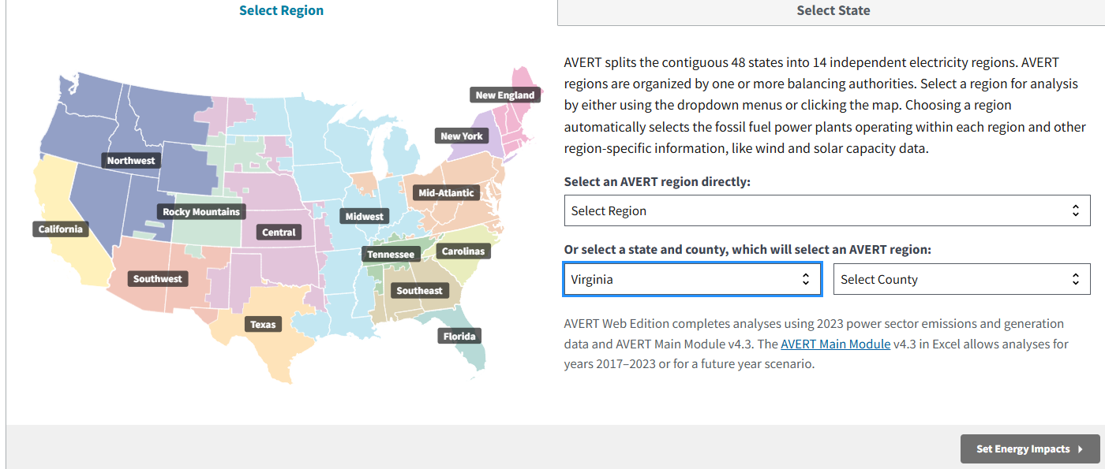
- Step 2: Establish the Base Year (2024) Using 2024 emissions outputs normalized by energy delivered, one estimate converted this intensity was converted to 57 gCO₂e/MJ, which is lower than the values shown previously. This represents the baseline carbon footprint of the Virginia grid.
- Step 3: Project the Target Year (2045) To capture long-term policy impacts—including the retirement of coal units and the expansion of solar and wind—a 2045 projection is needed. Different sets of assumptions will yield different results. For example, one set of assumptions was modeled using AVERT’s clean energy adoption assumptions. This resulted in a projected intensity of 14 gCO₂e/MJ, consistent with deep decarbonization pathways used in EPA and DOE scenario work.
- Step 4: Apply to Virginia Geographies. VisionEval requires values for each Azone (95 counties and 38 independent cities). The grid is managed regionally rather than by municipality, so ideally one would consider these different regions. That said, this approach could yield the same statewide values (57 for 2024; 14 for 2045) for all Azones.

Sources for the Appendix are:

- EPA AVERT Web Edition Tool. U.S. Environmental Protection Agency. https://www.epa.gov/avert/avert-web-edition
- Virginia Clean Economy Act (VCEA). Decarbonization requirements for Virginia utilities.
- U.S. Department of Energy (DOE). Deep Decarbonization Pathways and Scenario Projections.
- VisionEval Documentation. Model Input Requirements for Electricity Carbon Intensity. https://visioneval.github.io/docs/model-inputs.html
- Internal Analysis. CAGR Calculation for 2024–2045 projections (updated Sep, 2025-12-03).

SCRAP Work

https://www.epa.gov/energy/greenhouse-gas-equivalencies-calculator
Listing of all Zip Codes in the state of Virginia
Convert Kilowatt-hour to Megajoule
Greenhouse Gas Equivalencies Calculator - Calculations and References | US EPA https://www.unitconverters.net/energy/kilowatt-hour-to-megajoule.htm
Listing of all Zip Codes in the state of Virginia
Because 1 kwH = 3.6 MJ,
=.314 kg for 1 kwh
=.314 kg for 3.6 MJ
=314 g for 3.6 MJ
=314/3.6=87.222 g for 1 MJ
Complete List Of All Virginia Zip Codes – GenGuide’
Greenhouse Gas Equivalencies Calculator | US EPA
277.8

